Yoofi Brown-Pobee Individual Lab Assignment

Jumia Ghana Website Assessment

Homepage.

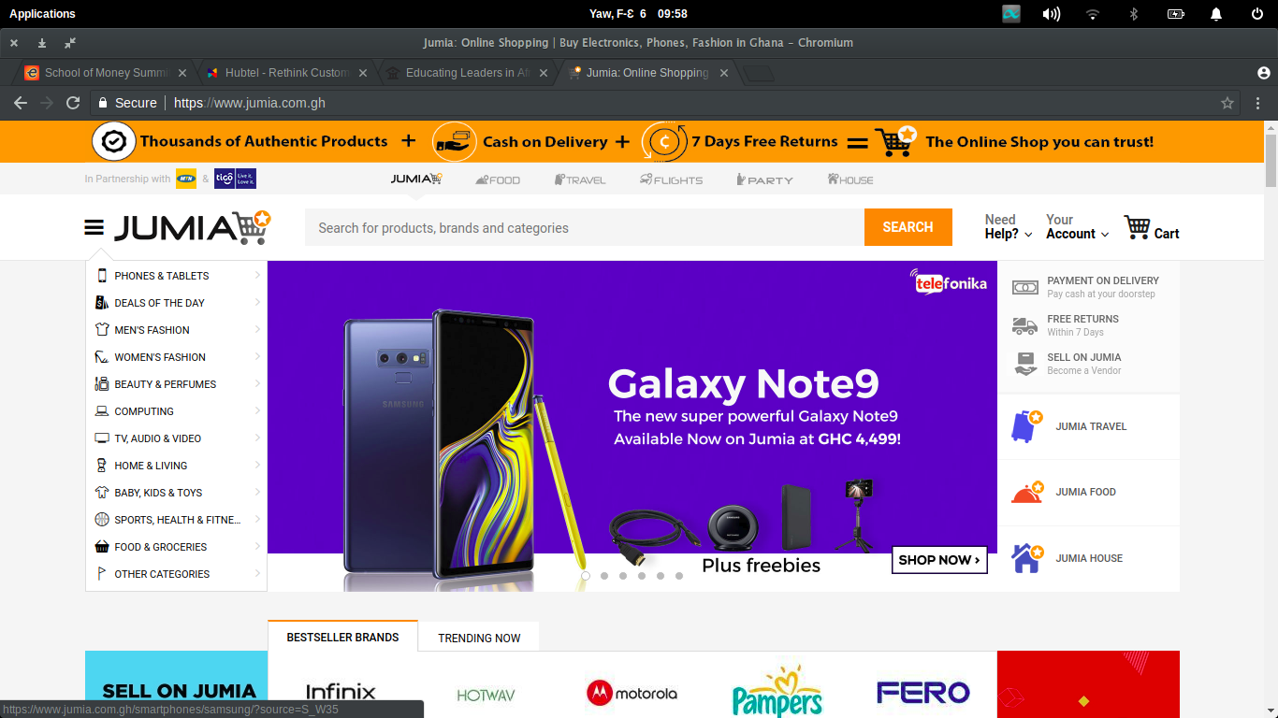

This is the landing page. When a user navigates to the website, this is the page they would find themselves on. In the middle of the page is a slide show featuring a few products on sale. This allows them to showcase products that a new, on-sale or popular to encourage sales. On the right side of the slide show are other e-commerce websites that are related to the Jumia store. In this way they are able to direct sales and traffic from their store to the other related sites. On the left side of the slide show are the different product categories. Hovering over the categories opens up a another menu of categories as show below:

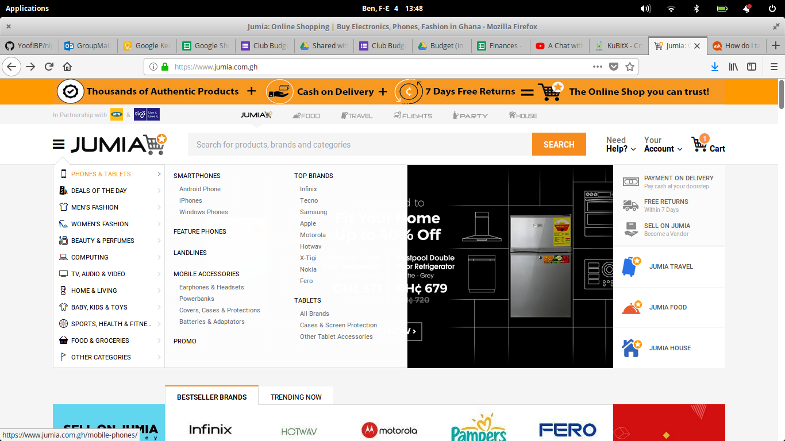

Users are able to carry out a more specific category search. Further down on the same page, products have been categorized into ‘sections’ as below:

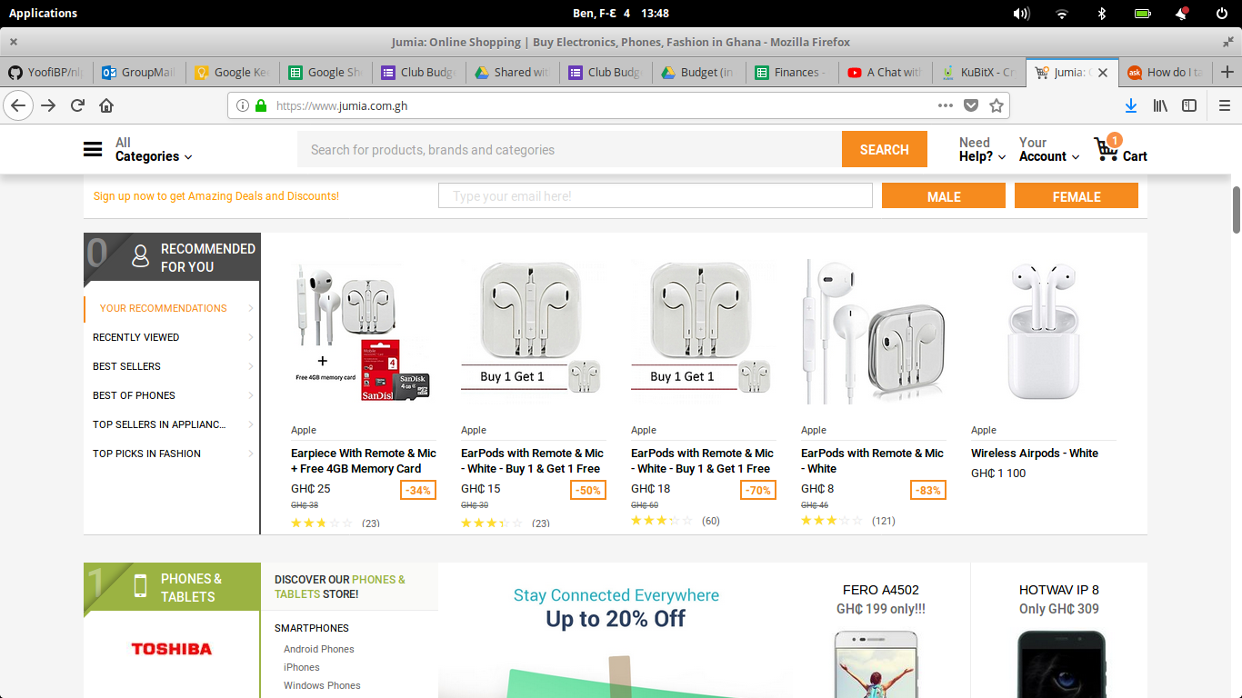

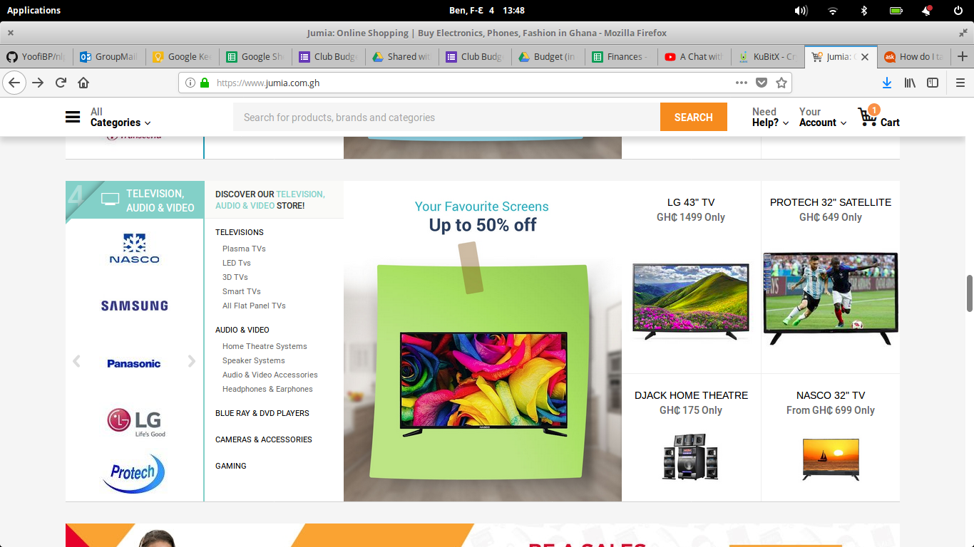

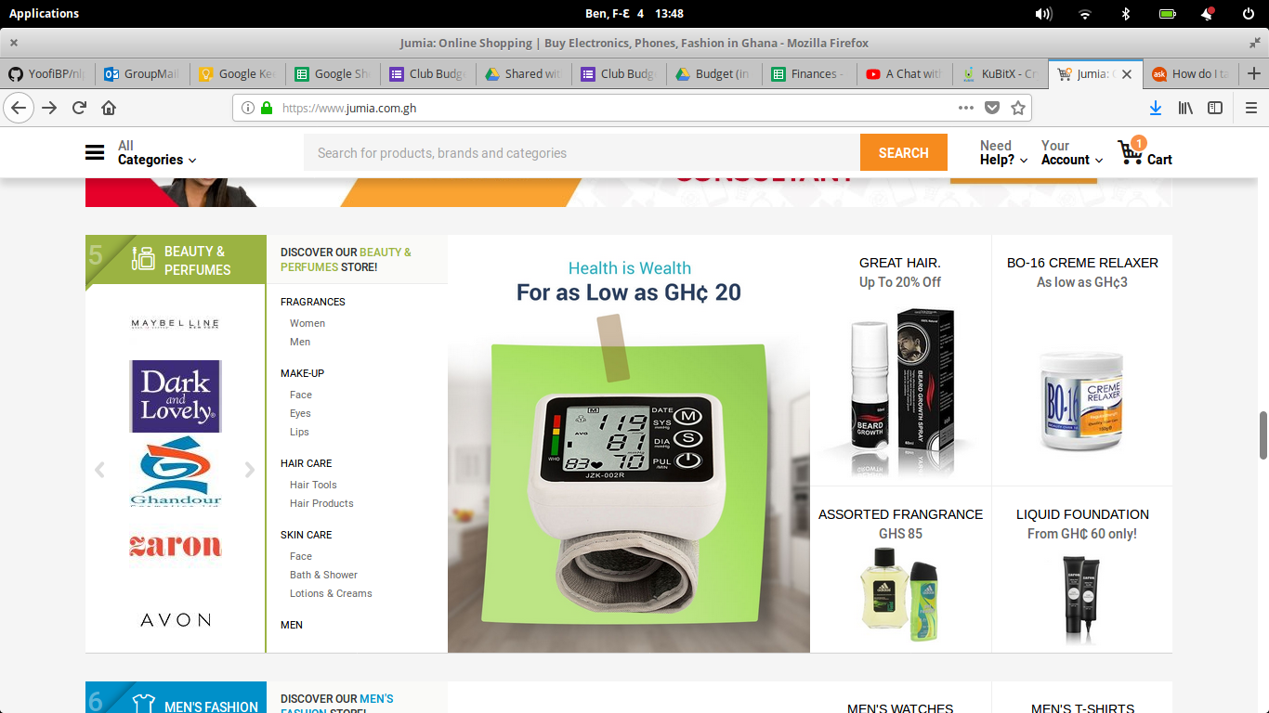

Different products are featured on each section to drive sales.

The page below can be found by navigating through the following pages from the categories on the left side at as: Phones & Tablets > Smartphones > iPhones.

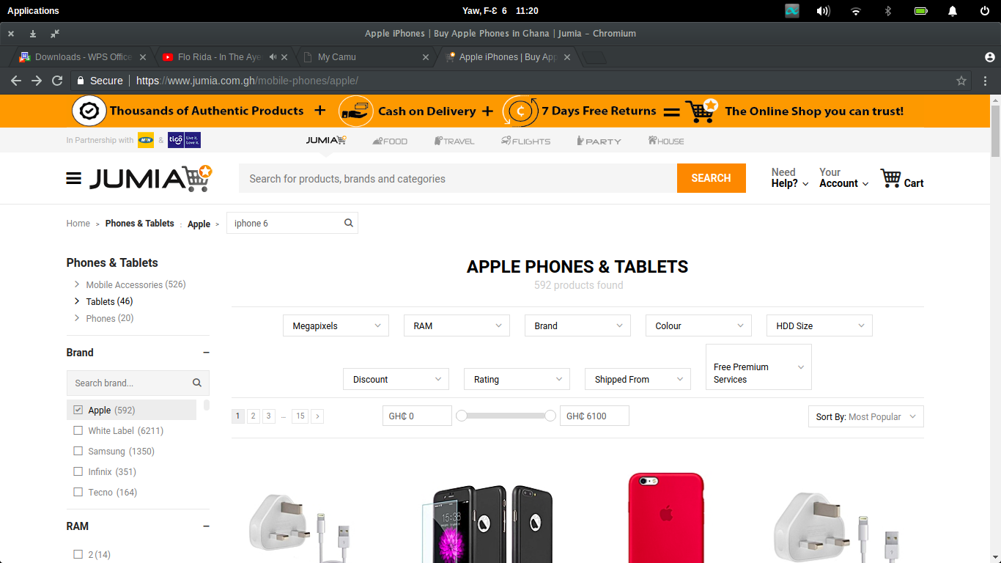

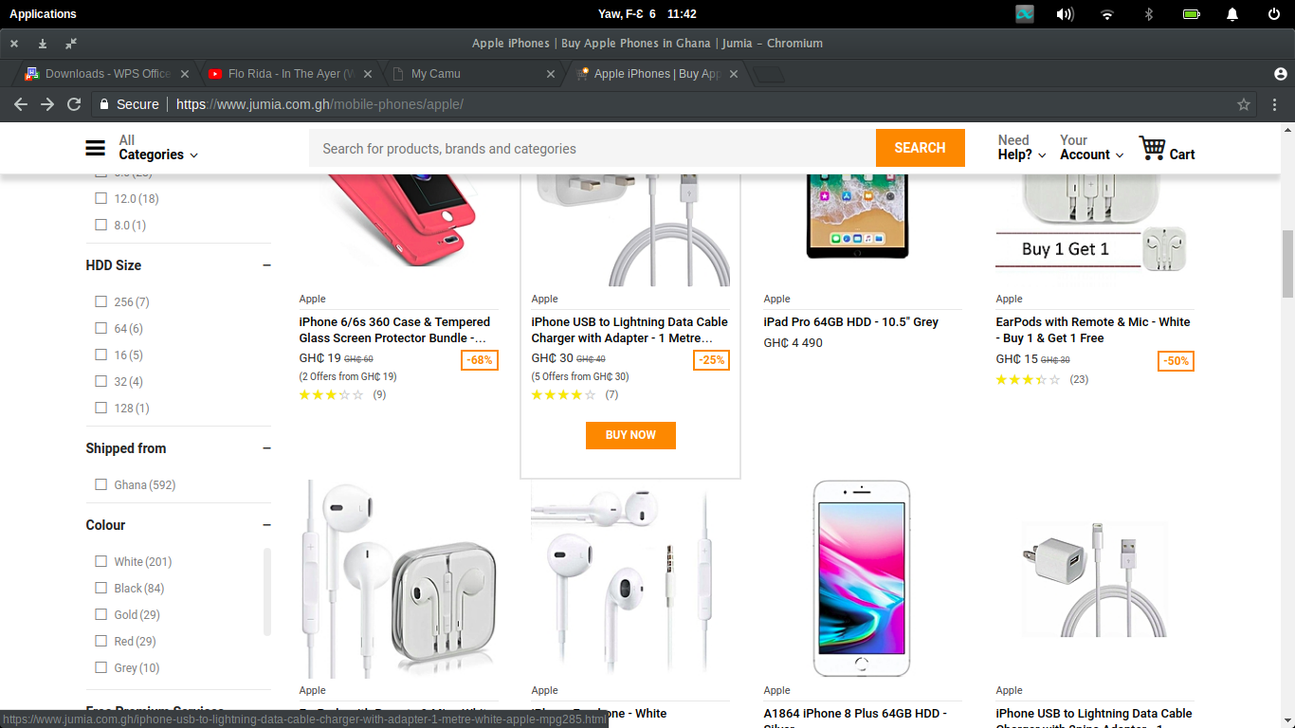

The products are categorized into a scrollable 4-column grid. Each cell in the grid showcases the product name, price, price reduction if it exists and product rating in stars. Hovering over the the cell makes a ‘BUY NOW’ button visible which makes it clear which product is currently selected. Beyond searching by scrolling throw the grid, the website has provided many search filters to make the search more specific evident in above. For example in the screenshot, the search can be narrowed by

* Number of megapixels
* Memory (RAM)
* Brand
* Colour
* HDD Size
* Amount of Discount offered
* Rating
* Location Shipped from
* Price

The filters can be found both at the top and at the left pane of the entire page. There is a responsive bar and text box that enables the customer to enter a price range for the product they are looking for. Users can also sort the categories by:

* Most Popular
* New Arrivals
* Best Rating
* Highest/Lowest Cost

There is also a search bar above the parameters that allows for more general searches. Upon clicking and typing into the search bar, the user is giving possible suggestions as shown in:

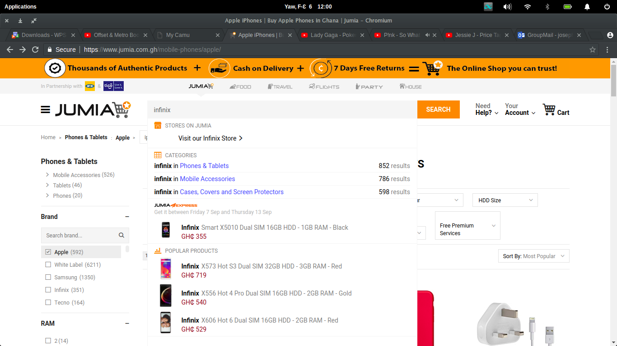

The many search parameters coupled with the sorting parameters make for a convenient product search experience as it is easy to go from general to more specific. In terms of navigation and layout, the pages are rather long and appear crowded. I had to be a little focused to identify the many parameters and functionalities available to me on the page. However the once this is understood the robust search and sort functionality makes for a convenient product search experience. Upon searching and choosing a product you are taking to the product details page shown below:

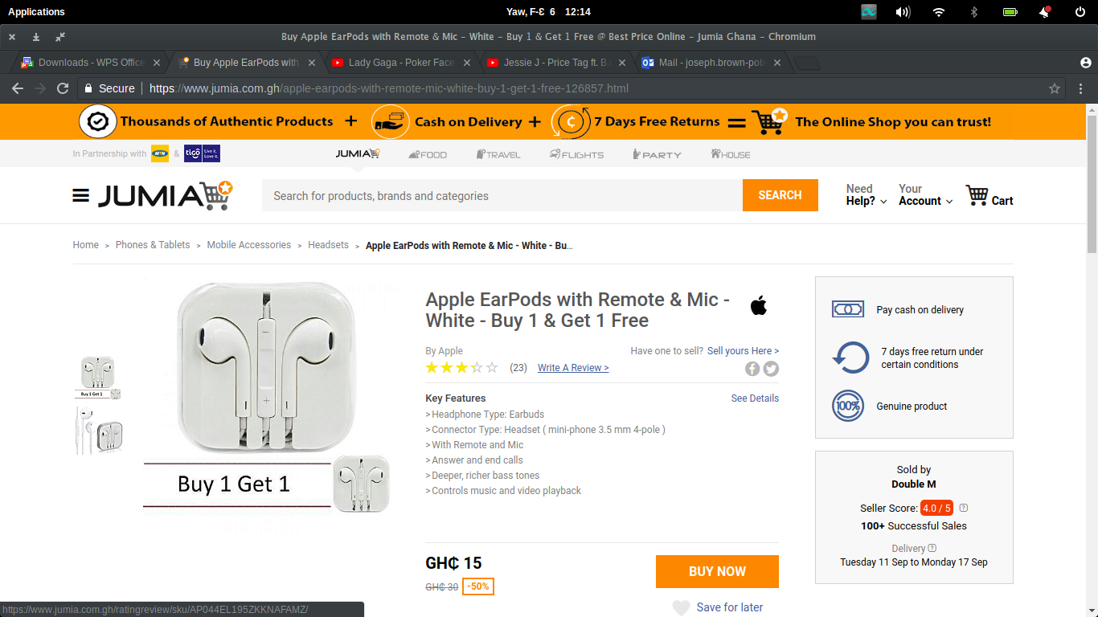

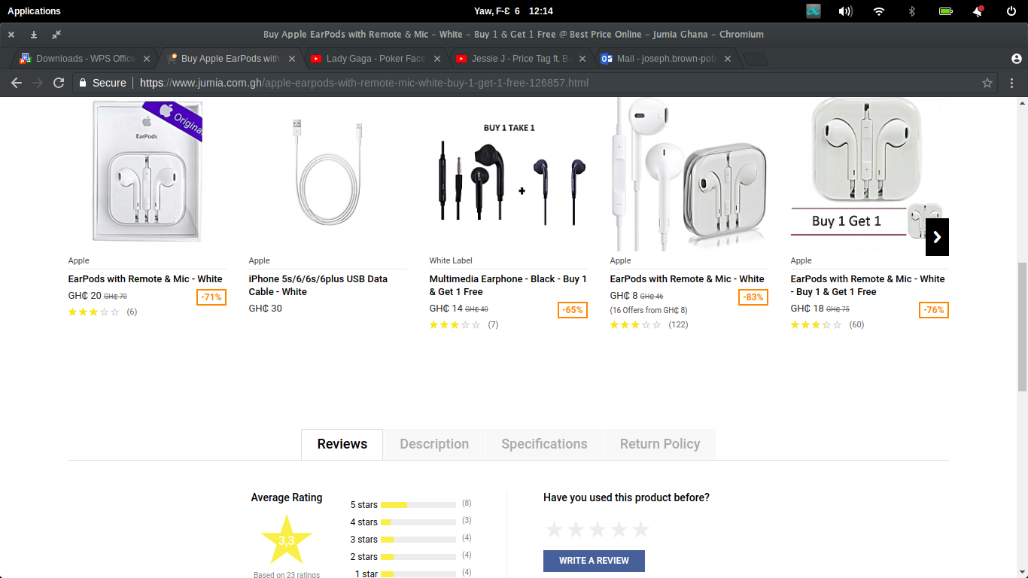

On the products page the user sees a lot more details about the product including its name, rating, price and key features. The user also has to option of saving the product for later thus requiring them to create an account or sign in as shown below:

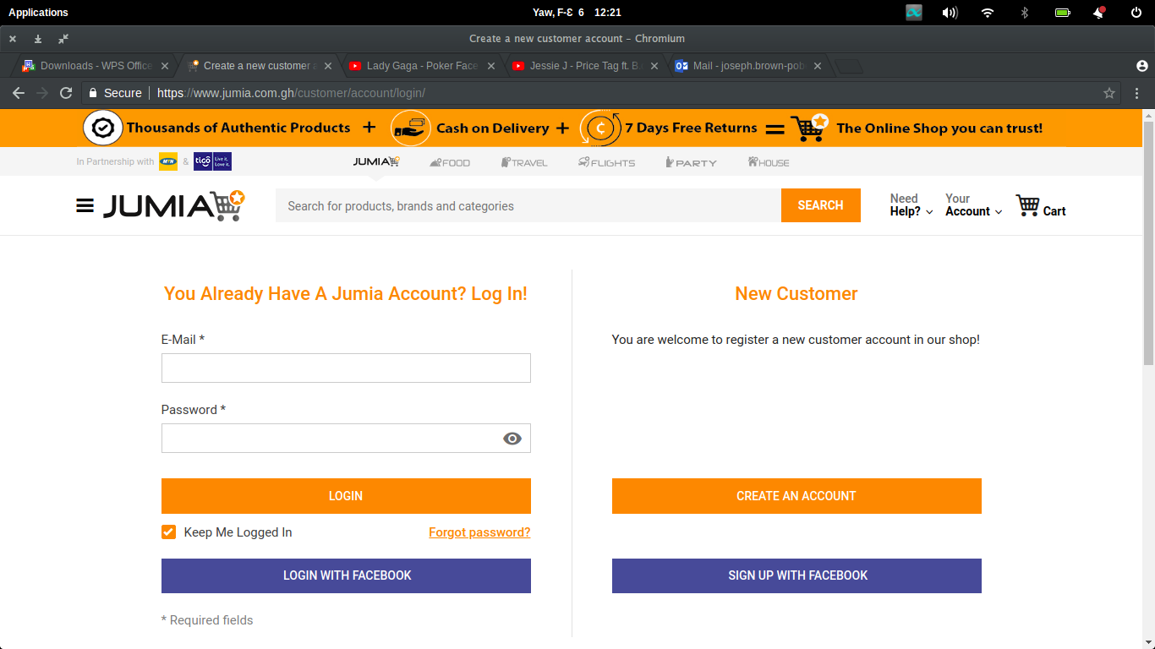Hovering over the product image creates a magnifier that allows to user to zoom in as shown below.

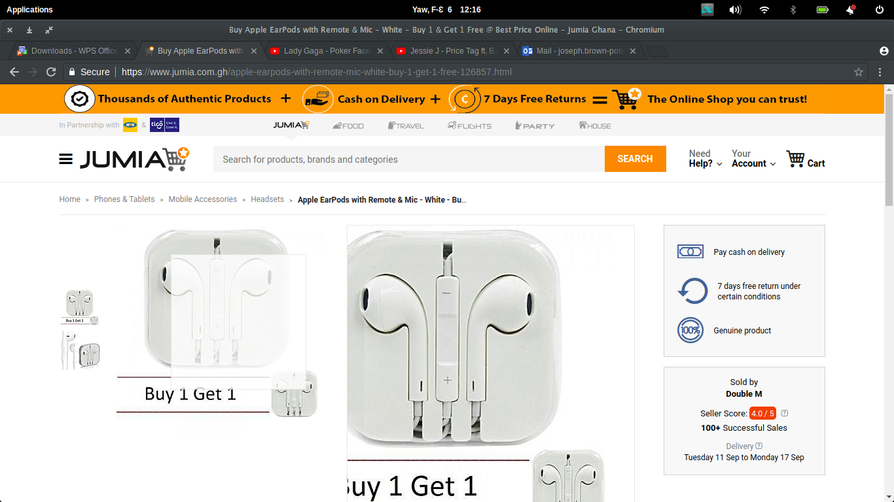

This allows the user to perform a better examination of the images being used to advertise the product. The user can also click the images at to get full size images for their perusal as shown below:

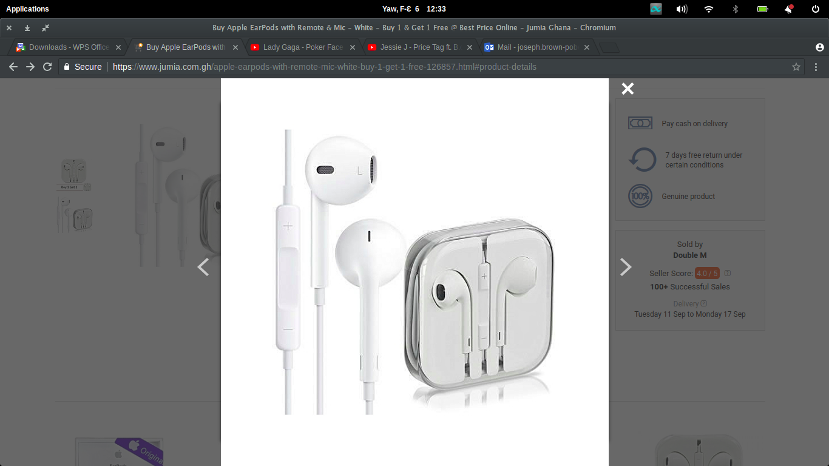

In addition to better viewing the pictures, the box on the bottom right section of the screen gives information about the seller including their score/rating, number of successful sales and available dates for delivery. There is also a see details hyperlink anchored to the bottom of the page where the user can view the product reviews, a more detailed product description, the product specifications and the return policy:

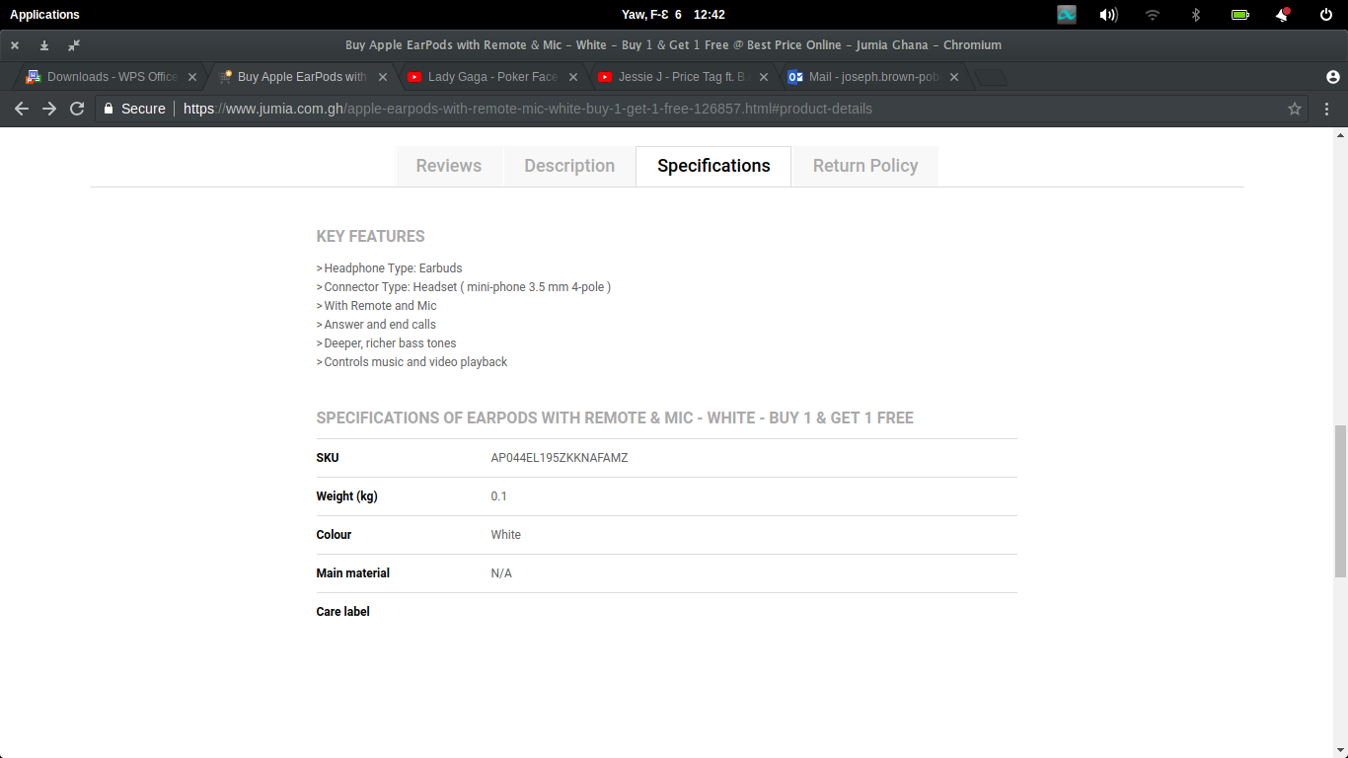

This gives the user further details about the product they are about to purchase to enable them make an informed decision. The use of separate tabs to store the information prevents the need to make the page longer resulting in a longer period scrolling. In between the product details and product picture sections is a section that features similar and related products based on the purchases of other customers:

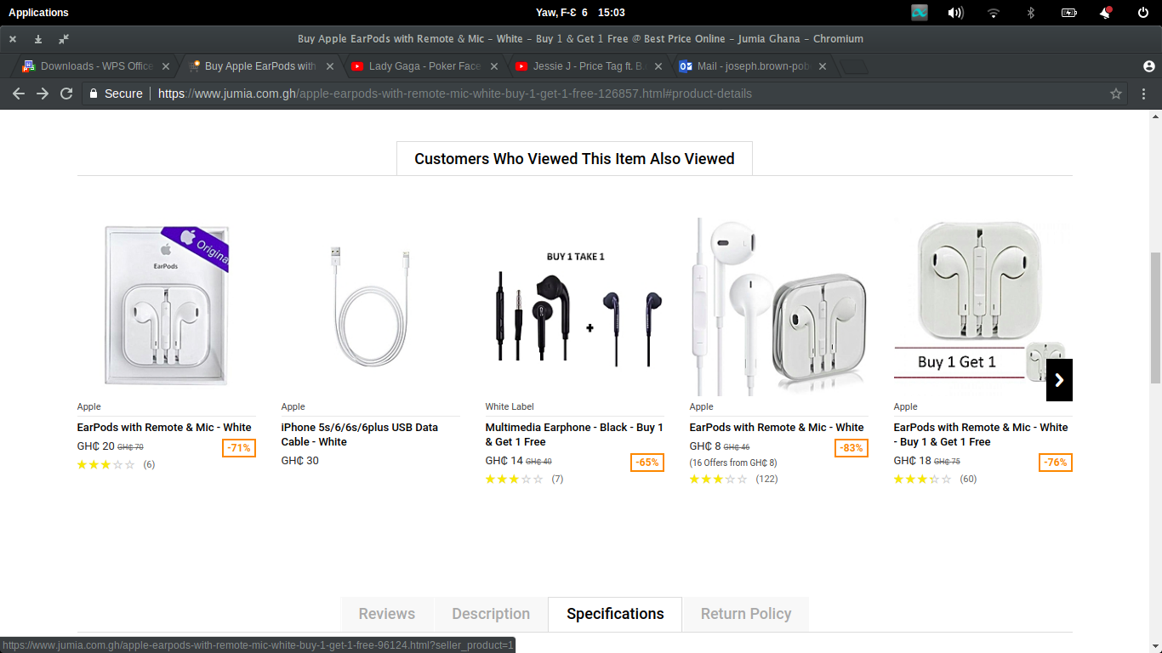

The suggestions serve both as a strategy for Jumia to increase sales by putting related products in front of the customer and as a convenience mechanism to enable customers find similar products without needing to carry out another search thereby making improving the entire online shopping experience. Going back to the product overview section and clicking buy now, the user is met with this dialog box that asks whether they would like to continue shopping or view their cart and proceed to checkout:

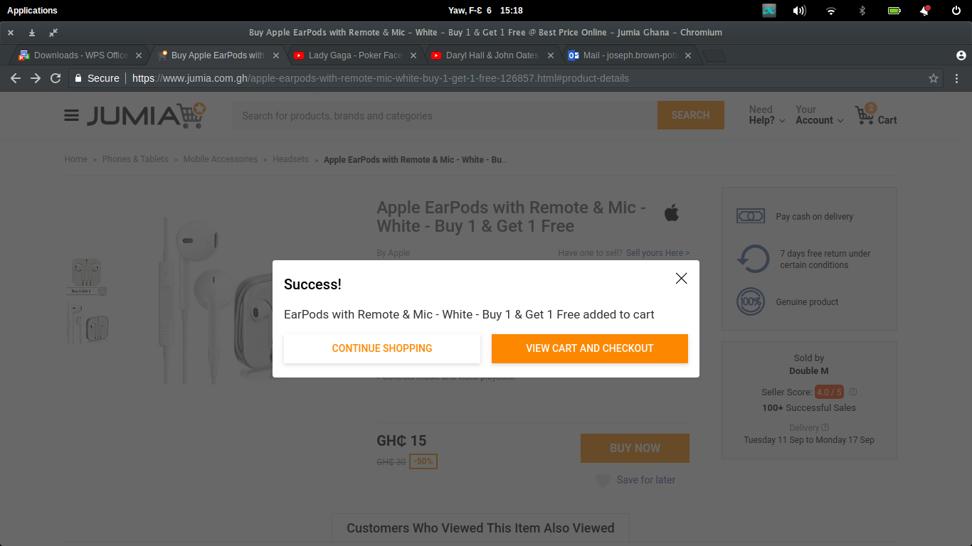

Clicking shopping closes the dialog box and allows the user to continue looking through the website for more products. This avoids leaving the page upon accidentally clicking the buy now button as well as allows for a user to change their mind about proceeding to checkout. Clicking view Cart and Checkout takes the user to this page:

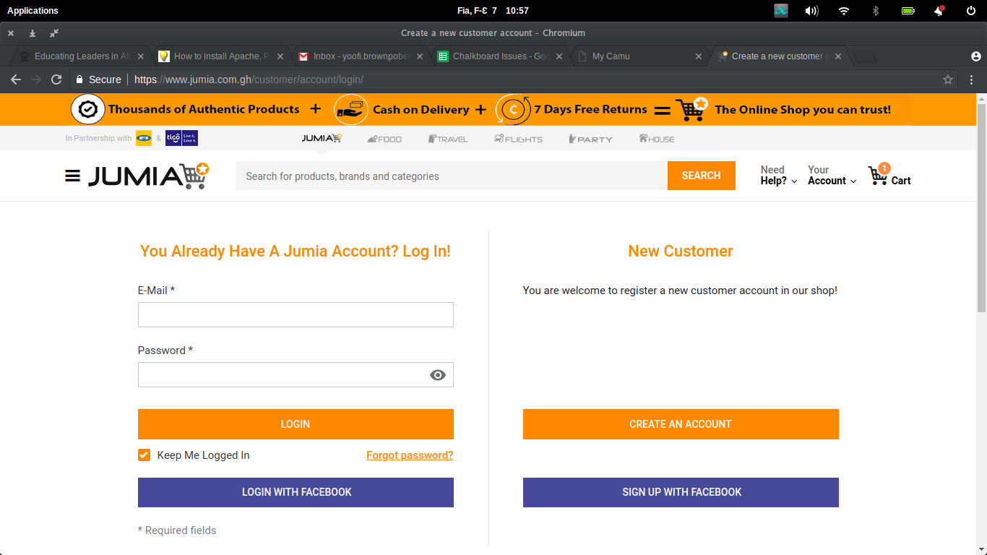The user is asked to log in if they have an account and create a new one of not. In this way the need to log in only appears at the end of the product selection experience selection process. These are the details it requires of you when you have to create an account;

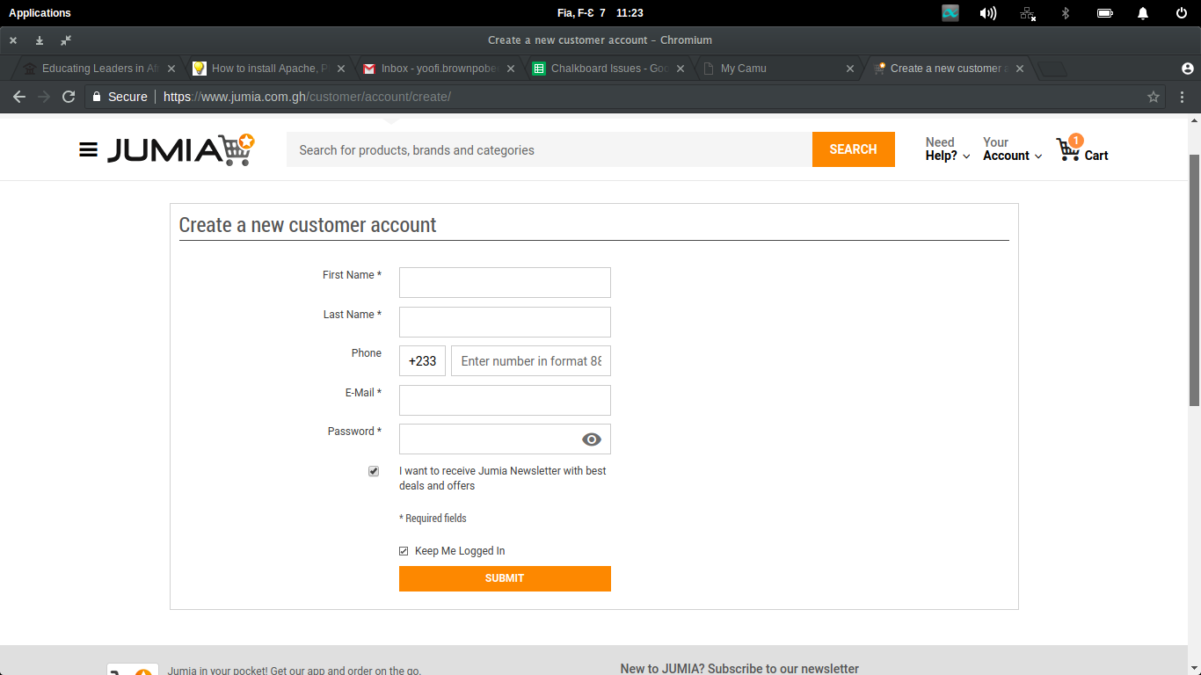

In terms of information required for registration, I found the details being asked for where quite concise enough. Longer form fields would have had a negative effect on the registration process. Filling in the form and submitting takes you to your user account control panel:

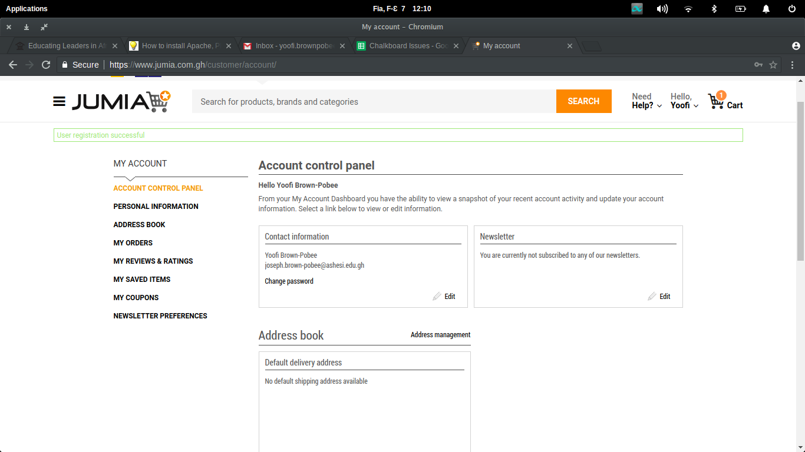

Here you are able to edit personal information, review your address, previous/current orders, ratings given, items saved, coupons you may possess and edit your preferences with respect to the newsletter sent periodically. In this way users are able to better manage their purchase experience by reviewing old purchase records, going back to saved items and changing personal information when there is a need to among others. It is easy to think that one has lost all checkout items as the page redirected to the control panel. However in the top right corner is a picture of a shopping cart with the number of items in the cart. This allows the user the return to the checkout to finish processing their orders.

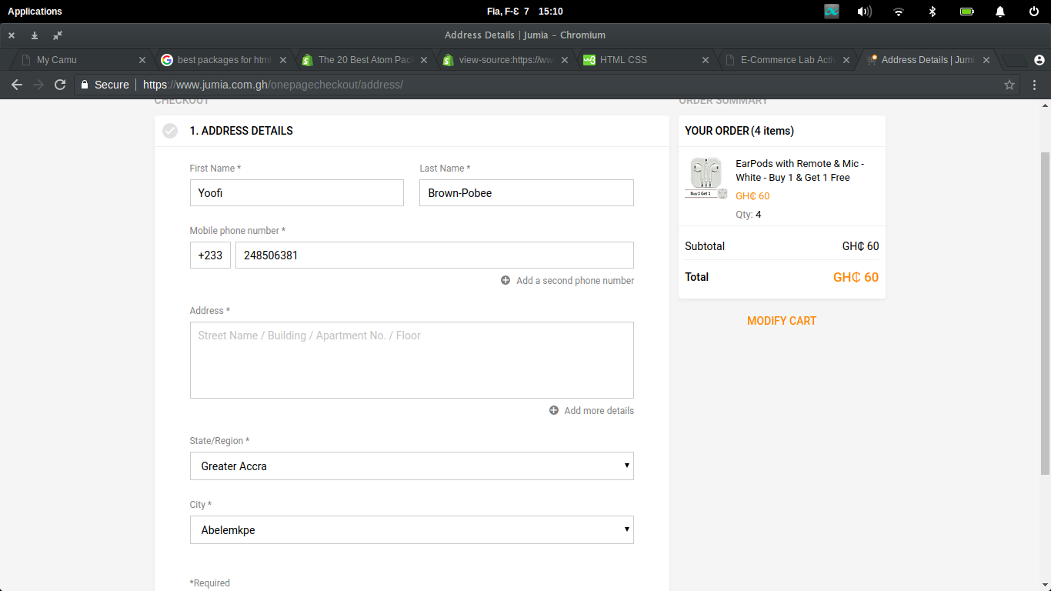

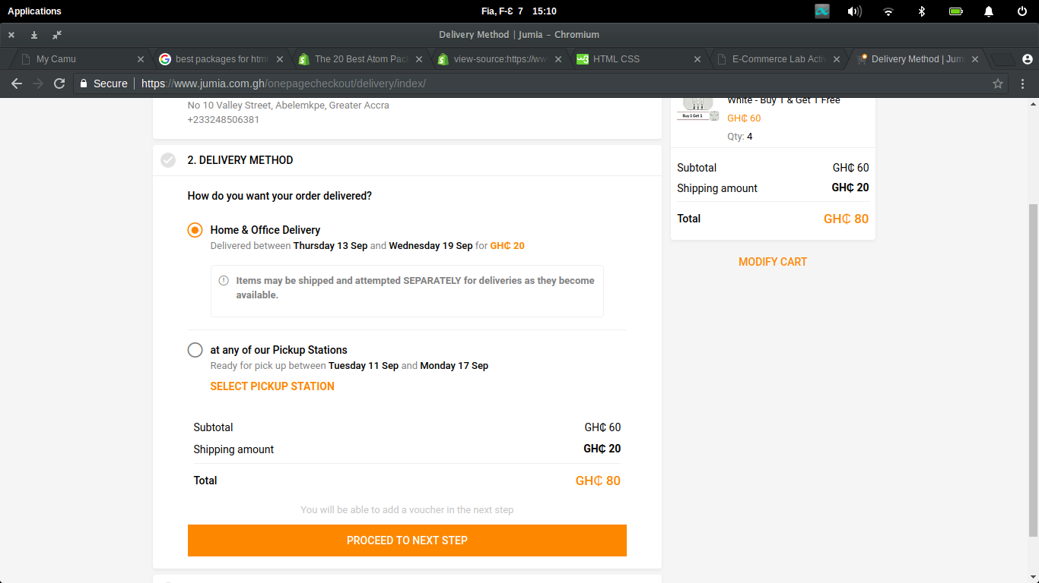

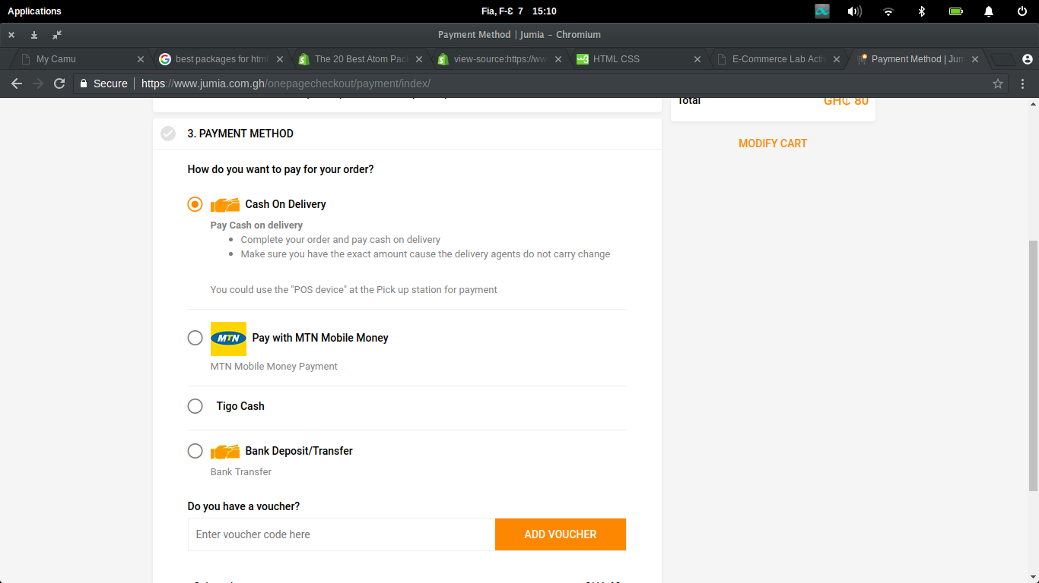

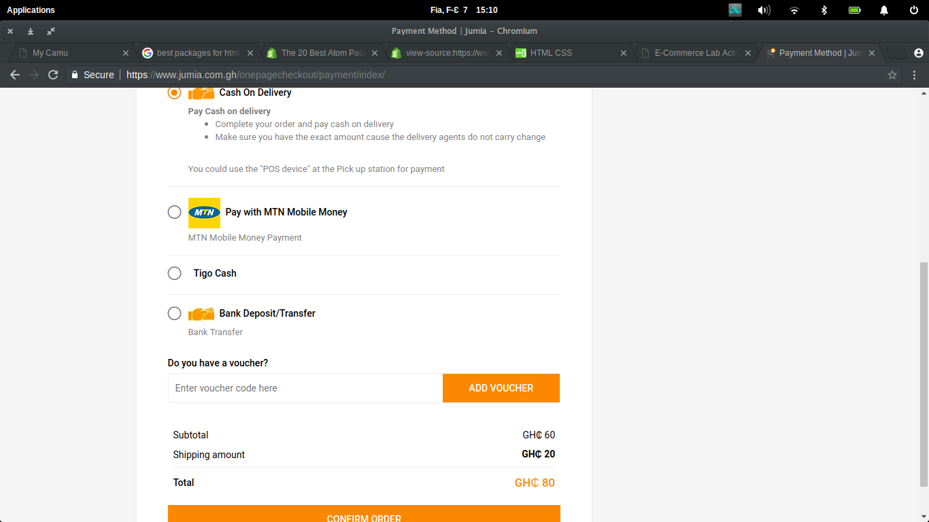

In the above screenshots we see how checkout is processed. The user is asked to fill-in/ confirm their personal details. I noticed that some of the information is already pre-filled using information obtained from the account control panel. The user is then given delivery options to choose from after which they choose their preferred payment method before confirming the order. A greater feature on this pay is the ability to modify your cart (the upper right section) if there are any changes you could make. After checking out you are able to view the status of your orders in the aforementioned ‘My Orders’ section in your control panel.